Software Engineering
Prototype Assignment
Project Name: Carrefour System
Group Members :-
- Muhammad Ali Faraz (F2024065247)
- Muhammad Hasanat Khan (F2024065242)

Carrefoue Start Up Logo



Login Page

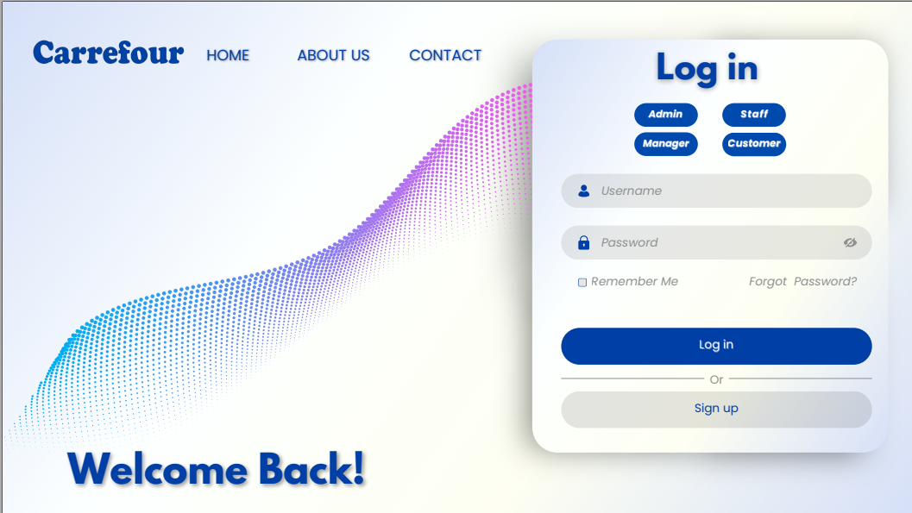

Create account Page

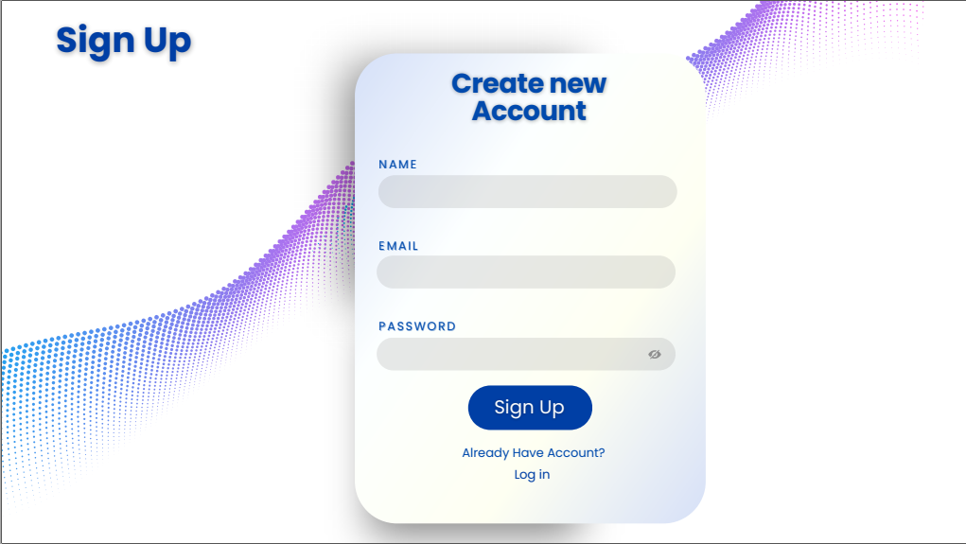

Admin Dashboard

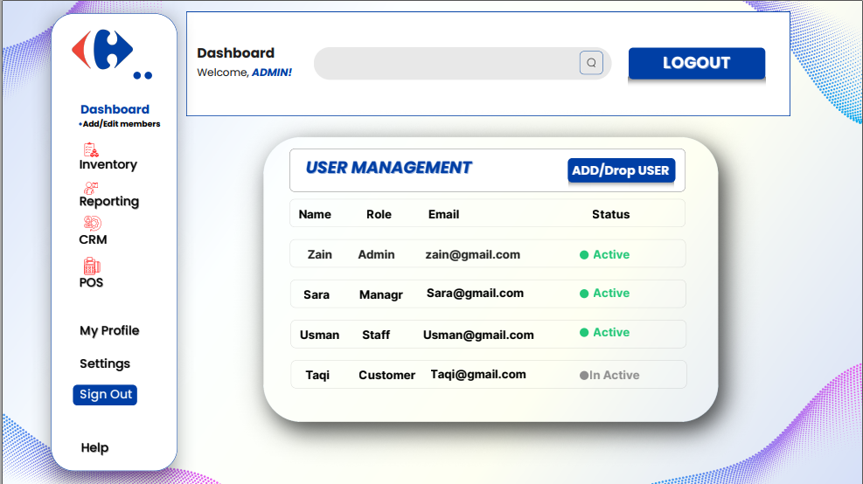

Manager Dashboard
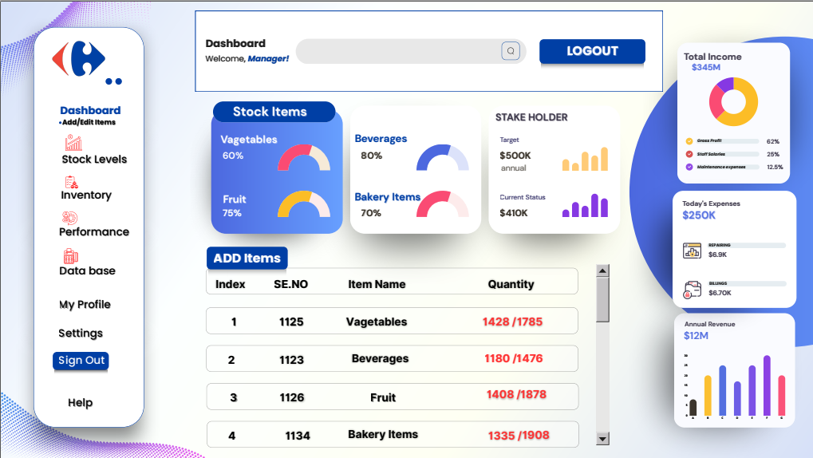
Cashier Dashboard

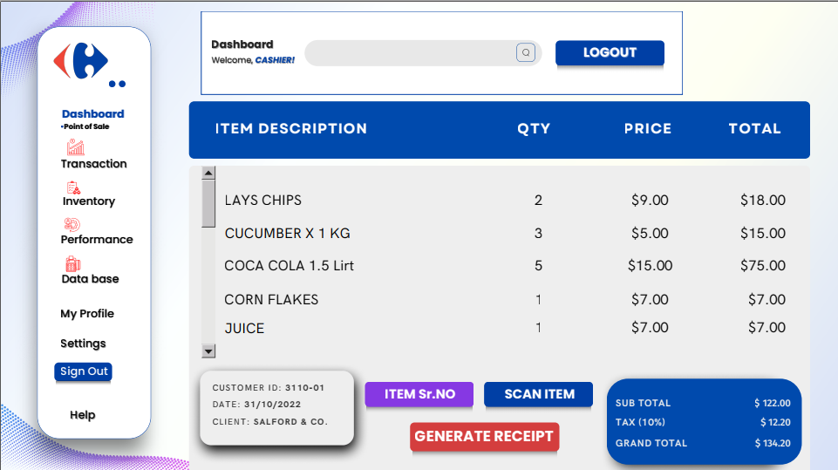

Customer Homepage



